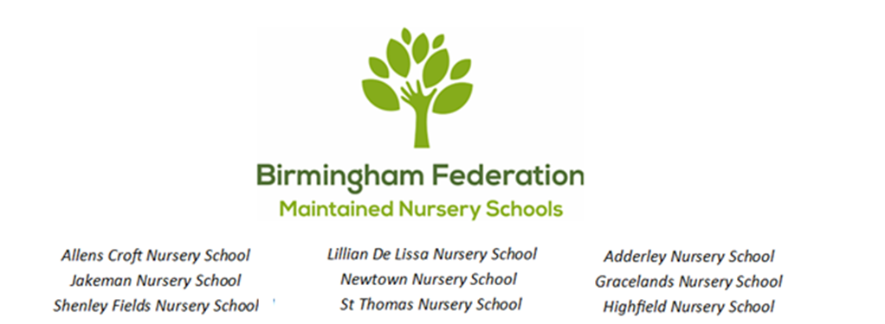

Admissions Policy
Shenley Fields Nursery School

Shenley Fields Nursery School follows the Local Authority guidance for admissions for the 15-hour entitlement for children 9 months and over and the 30 hours Early Education Entitlement (EEE) for eligible families of children 9 months and over.

The school has the following places available for children:

‘Sunshine’: 9 places for babies aged from 3 months to 2 years
‘Raindrops’: 52 FTE places for children aged 2-3
‘Sunbeams’: 62 FTE places for children aged 3-4

All of these places are term time only.

Raindrops (2-3 year olds)

Free places for 2 year olds:

Birmingham City Council offers an early education entitlement for two year old children to support the most disadvantaged families in the city. Eligible 2 year olds will be entitled to 15 hours per week of provision for 38 weeks of the year, the school term after their second birthday.

Eligible working parents of 2-year-olds will be entitled to 15 hours per week of provision for 38 weeks of the year, the school term after their second birthday.

Shenley Fields Daycare and Nursery School offers both of the above as a two and a half (2.5) day block during term time as follows:

Monday 9.00am - 3.00pm
Tuesday 9.00am - 3.00pm
& Wednesday 9.00am - 12.00 Noon

OR

Wednesday 12.15pm – 3.15pm
Thursday 9.00am – 3.00pm
& Friday 9.00am – 3.00pm

Sunbeams (3-4 year old children)

All children in Sunbeams are eligible for 15 hour per week of provision for 38 weeks of the year, the school term after their third birthday

Shenley Fields Daycare and Nursery School offers this as a two and a half (2.5) day block during term time as follows:

Monday 9.00am - 3.00pm
Tuesday 9.00am - 3.00pm
& Wednesday 9.00am - 12.00 Noon

OR

Wednesday 12.15pm – 3.15pm
Thursday 9.00am – 3.00pm
& Friday 9.00am – 3.00pm

We do not admit children of Reception age to our setting but we will work with families to support their application for a suitable school place for their child.

30 Hour Entitlement:

Our school offers those entitled to a 30 hour per week place provision between 9.00am – 3.00pm Monday – Friday.

Fee Paying Places:

Parents can also pay for places at our school. Please see our Charging Policy.

Where there are more applications than there are places available, places will be offered based on the oversubscription criteria which is as follows:

Priority 1 - Looked after or previously looked after children
Priority 2 - Siblings with an older brother or sister at the school (or at a school on the same site) who will still be in attendance at the same time as their sibling enters the school.
Priority 3 - Distance from the school
If you have any concerns based on decisions made using the oversubscription criteria, please refer to our complaints policy.

Holiday Club Places:
We offer fee-paying holiday club places, during some of the school holidays, for children that attend our school. These are available only for children of 2+ years. They are offered on a first come – first served basis. We do not have any additional staff to offer specialist support during the holidays and this can mean that there are some needs that cannot be accommodated within the holiday periods.

See https://www.childcarechoices.gov.uk for further information on your childcare entitlement.

Date Policy Adopted:
Local Committee: 20.10.2025
Full Governing Board: 8.12.2025
Date for next renewal: Autumn Term 2026

Signed: ____________________________ Sally Andrews
Chair of Local Committee

Signed: ____________________________ Sean Delaney
Chair of Governors

Signed: ____________________________ David Aldworth
Executive Head Teacher

